**AZURE CLI**

**INTRODUCTION**

* Like aws-cli in AWS

**1. Installation**

**https://learn.microsoft.com/en-us/cli/azure/install-azure-cli-linux?pivots=apt**

* curl -sL https://aka.ms/InstallAzureCLIDeb | sudo bash

**2. Login**

* az login

**3. Other commands**

* az vm list -o table | az vm list

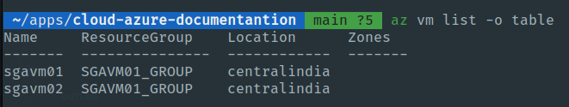

* az group create --name "vmgabriel-02" --location eastus2

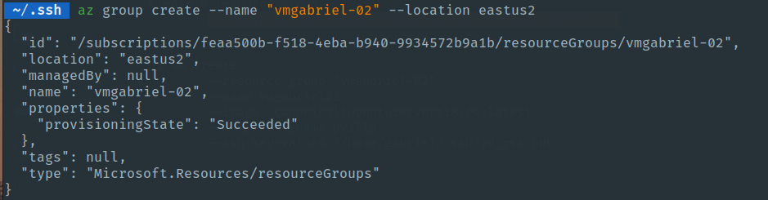

* az vm create \

--resource-group "vmgabriel-02" \

--name vmgabriel02 \

--image 'Canonical:UbuntuServer:18.04-LTS:latest' \

--admin-username pvilla \

--ssh-key-values '/home/gabriel/.ssh/id_rsa.pub' \

--output json

